DESIGN AND ANALYSIS OF ALGORITMS
LAB 6
1. Maximum and Minimum using Divide and Conquer
Code:
#include <stdio.h>

struct Result {
int max;
int min;
};

struct Result findMaxMin(int a[], int low, int high) {
struct Result r, left, right;
int mid;

if (low == high) {
r.max = a[low];
r.min = a[low];
return r;
}

if (high == low + 1) {
if (a[low] > a[high]) {
r.max = a[low];
r.min = a[high];
} else {
r.max = a[high];
r.min = a[low];
}
return r;
}

mid = (low + high) / 2;

left = findMaxMin(a, low, mid);
right = findMaxMin(a, mid + 1, high);

r.max = (left.max > right.max) ? left.max : right.max;
r.min = (left.min < right.min) ? left.min : right.min;

return r;
}

int main() {
int n, i;
int a[100];
struct Result result;

printf("Enter the number of elements: ");
scanf("%d", &n);

printf("Enter the elements:\n");
for (i = 0; i < n; i++) {
scanf("%d", &a[i]);
}

result = findMaxMin(a, 0, n - 1);

printf("\nArray: ");
for (i = 0; i < n; i++) {
printf("%d ", a[i]);
}

printf("\n\nMaximum element = %d", result.max);
printf("\nMinimum element = %d\n", result.min);

return 0;
}
Output:
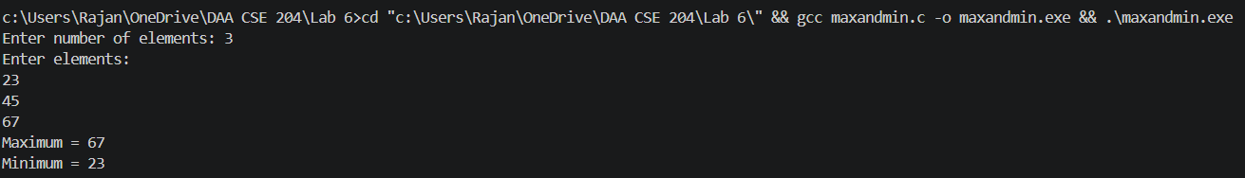

2. Maximum Subarray Problem using Divide and Conquer
Code:
#include <stdio.h>

int max(int a, int b) {
return (a > b) ? a : b;
}

int maxCrossingSum(int a[], int low, int mid, int high) {
int leftSum = -999999;
int rightSum = -999999;
int sum = 0;
int i;

for (i = mid; i >= low; i--) {
sum = sum + a[i];

if (sum > leftSum)
leftSum = sum;
}

sum = 0;

for (i = mid + 1; i <= high; i++) {
sum = sum + a[i];

if (sum > rightSum)
rightSum = sum;
}

return leftSum + rightSum;
}

int maxSubarraySum(int a[], int low, int high) {
int mid;
int leftSum, rightSum, crossSum;

if (low == high)
return a[low];

mid = (low + high) / 2;

leftSum = maxSubarraySum(a, low, mid);
rightSum = maxSubarraySum(a, mid + 1, high);
crossSum = maxCrossingSum(a, low, mid, high);

return max(max(leftSum, rightSum), crossSum);
}

int main() {
int n, i, result;
int a[100];

printf("Enter the number of elements: ");
scanf("%d", &n);

printf("Enter the elements:\n");
for (i = 0; i < n; i++) {
scanf("%d", &a[i]);
}

result = maxSubarraySum(a, 0, n - 1);

printf("\nArray: ");
for (i = 0; i < n; i++) {
printf("%d ", a[i]);
}

printf("\n\nMaximum subarray sum = %d\n", result);

return 0;
}
Output:
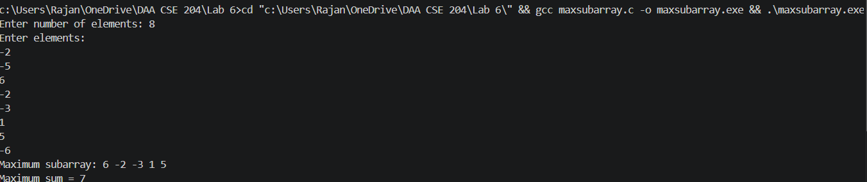

3. Strassen's Matrix Multiplication
Code:
#include <stdio.h>

#define MAX 8

void addMatrix(int A[MAX][MAX], int B[MAX][MAX],
int C[MAX][MAX], int n) {
int i, j;

for (i = 0; i < n; i++) {
for (j = 0; j < n; j++) {
C[i][j] = A[i][j] + B[i][j];
}
}
}

void subtractMatrix(int A[MAX][MAX], int B[MAX][MAX],
int C[MAX][MAX], int n) {
int i, j;

for (i = 0; i < n; i++) {
for (j = 0; j < n; j++) {
C[i][j] = A[i][j] - B[i][j];
}
}
}

void strassen(int A[MAX][MAX], int B[MAX][MAX],
int C[MAX][MAX], int n) {
int i, j;
int half;

int A11[MAX][MAX], A12[MAX][MAX];
int A21[MAX][MAX], A22[MAX][MAX];
int B11[MAX][MAX], B12[MAX][MAX];
int B21[MAX][MAX], B22[MAX][MAX];

int M1[MAX][MAX], M2[MAX][MAX];
int M3[MAX][MAX], M4[MAX][MAX];
int M5[MAX][MAX], M6[MAX][MAX];
int M7[MAX][MAX];

int T1[MAX][MAX], T2[MAX][MAX];

if (n == 1) {
C[0][0] = A[0][0] * B[0][0];
return;
}

half = n / 2;

for (i = 0; i < half; i++) {
for (j = 0; j < half; j++) {
A11[i][j] = A[i][j];
A12[i][j] = A[i][j + half];
A21[i][j] = A[i + half][j];
A22[i][j] = A[i + half][j + half];

B11[i][j] = B[i][j];
B12[i][j] = B[i][j + half];
B21[i][j] = B[i + half][j];
B22[i][j] = B[i + half][j + half];
}
}

addMatrix(A11, A22, T1, half);
addMatrix(B11, B22, T2, half);
strassen(T1, T2, M1, half);

addMatrix(A21, A22, T1, half);
strassen(T1, B11, M2, half);

subtractMatrix(B12, B22, T2, half);
strassen(A11, T2, M3, half);

subtractMatrix(B21, B11, T2, half);
strassen(A22, T2, M4, half);

addMatrix(A11, A12, T1, half);
strassen(T1, B22, M5, half);

subtractMatrix(A21, A11, T1, half);
addMatrix(B11, B12, T2, half);
strassen(T1, T2, M6, half);

subtractMatrix(A12, A22, T1, half);
addMatrix(B21, B22, T2, half);
strassen(T1, T2, M7, half);

for (i = 0; i < half; i++) {
for (j = 0; j < half; j++) {
C[i][j] = M1[i][j] + M4[i][j] - M5[i][j] + M7[i][j];

C[i][j + half] = M3[i][j] + M5[i][j];

C[i + half][j] = M2[i][j] + M4[i][j];

C[i + half][j + half] =
M1[i][j] - M2[i][j] + M3[i][j] + M6[i][j];
}
}
}

int main() {
int A[MAX][MAX], B[MAX][MAX], C[MAX][MAX];
int n, i, j;

printf("Enter the size of the square matrices: ");
scanf("%d", &n);

printf("\nEnter elements of Matrix A:\n");
for (i = 0; i < n; i++) {
for (j = 0; j < n; j++) {
scanf("%d", &A[i][j]);
}
}

printf("\nEnter elements of Matrix B:\n");
for (i = 0; i < n; i++) {
for (j = 0; j < n; j++) {
scanf("%d", &B[i][j]);
}
}
strassen(A, B, C, n);
printf("\nResultant Matrix using Strassen's Algorithm:\n");

for (i = 0; i < n; i++) {
for (j = 0; j < n; j++) {
printf("%d\t", C[i][j]);
}
printf("\n");
}

return 0;
}
Output:
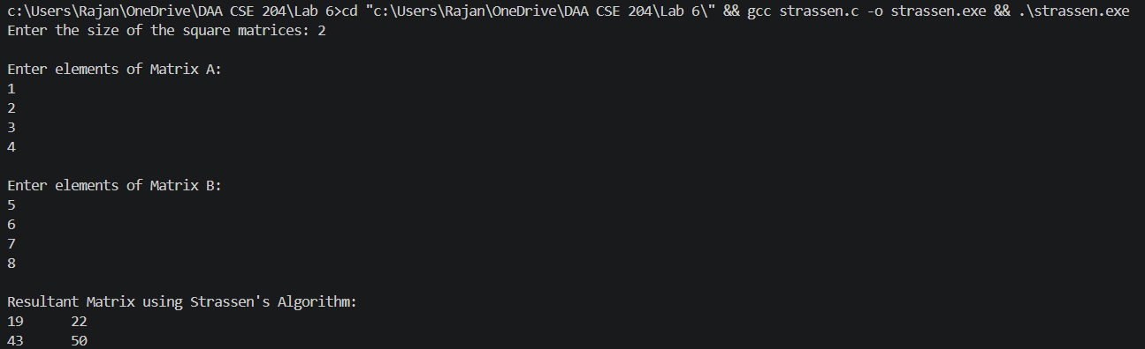
4. Fractional Knapsack using Greedy Approach
Code:
#include <stdio.h>

struct Item {
int weight;
int profit;
float ratio;
};

int main() {
struct Item items[100], temp;
int n, capacity;
int i, j;
float totalProfit = 0.0;
float fraction;

printf("Enter the number of items: ");
scanf("%d", &n);

printf("Enter the weight and profit of each item:\n");

for (i = 0; i < n; i++) {
printf("Item %d weight: ", i + 1);
scanf("%d", &items[i].weight);

printf("Item %d profit: ", i + 1);
scanf("%d", &items[i].profit);

items[i].ratio =
(float)items[i].profit / items[i].weight;
}
printf("\nEnter the capacity of the knapsack: ");
scanf("%d", &capacity);

for (i = 0; i < n - 1; i++) {
for (j = i + 1; j < n; j++) {
if (items[i].ratio < items[j].ratio) {
temp = items[i];
items[i] = items[j];
items[j] = temp;
}
}
}
printf("\nItems sorted according to Profit/Weight ratio:\n");
printf("Item\tWeight\tProfit\tRatio\n");
for (i = 0; i < n; i++) {
printf("%d\t%d\t%d\t%.2f\n",
i + 1,
items[i].weight,
items[i].profit,
items[i].ratio);
}

printf("\nSelected items:\n");

for (i = 0; i < n; i++) {

if (capacity >= items[i].weight) {
capacity = capacity - items[i].weight;
totalProfit = totalProfit + items[i].profit;

printf("Item with weight %d: 100%% taken\n",
items[i].weight);
}
else if (capacity > 0) {
fraction = (float)capacity / items[i].weight;

totalProfit =
totalProfit + items[i].profit * fraction;

printf("Item with weight %d: %.2f%% taken\n",
items[i].weight,
fraction * 100);

capacity = 0;
}
}

printf("\nMaximum Profit = %.2f\n", totalProfit);

return 0;
}
Output:
